LAB 9 ANP-C7781

Solve following questions:

1. Perform the following tasks:

a. Create Student table with following attributes (STUDENT_ID , FIRST_NAME, LAST_NAME, PHONE_NUMBER, MARKS, COURSE_ID).

b. Create Course table with following attributes (COURSE_ID, COURSE_NAME).

c. Write a SQL statement to insert 8 records with your own value into the tables.

d. Write a query to get the number of students with the same course.

f. Write a query to get the student name, course name and marks of the students.

g. Write a query to get the Average marks of students course wise.

Program :-

CREATE DATABASE Student;

USE Student;



CREATE TABLE Student (

STUDENT_ID INT PRIMARY KEY,

FIRST_NAME VARCHAR(50),

LAST_NAME VARCHAR(50),

PHONE_NUMBER VARCHAR(15),

MARKS INT,

COURSE_ID INT,

FOREIGN KEY (COURSE_ID) REFERENCES Course(COURSE_ID)

);



CREATE TABLE Course (

COURSE_ID INT PRIMARY KEY,

COURSE_NAME VARCHAR(50)

);



INSERT INTO Course (COURSE_ID, COURSE_NAME) VALUES

(1, 'OOPS'),

(2, 'JAVA'),

(3, 'C++'),

(4, 'PYTHON'),

(5, 'C#'),

(6, 'MONGODB'),

(7, 'KAFKA'),

(8, 'JS');



INSERT INTO Student (STUDENT_ID, FIRST_NAME, LAST_NAME, PHONE_NUMBER, MARKS, COURSE_ID) VALUES

(1, 'Pranay', 'Surve', '8291424510', 85, 1),

(2, 'Manali', 'Patil', '8957512568', 90, 2),

(3, 'Rashmita', 'Gade', '9824258762', 88, 1),

(4, 'Ashlesha', 'Kasavkar', '9875468952', 92, 3),

(5, 'Reshma', 'Puri', '7968548952', 75, 2),

(6, 'Siddhesh', 'Chawatekar', '9659875985', 80, 4),

(7, 'Mahesh', 'Magar', '9798549856', 85, 3),

(8, 'Sampada', 'Margaj', '8542598575', 78, 1);



SELECT COURSE_ID, COUNT(STUDENT_ID) AS NumberOfStudents

FROM Student

GROUP BY COURSE_ID;

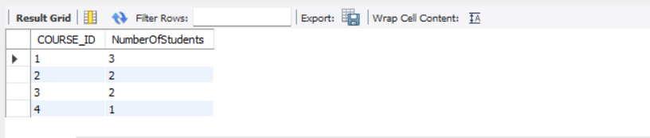

SELECT s.FIRST_NAME, s.LAST_NAME, c.COURSE_NAME, s.MARKS

FROM Student s

JOIN Course c ON s.COURSE_ID = c.COURSE_ID;

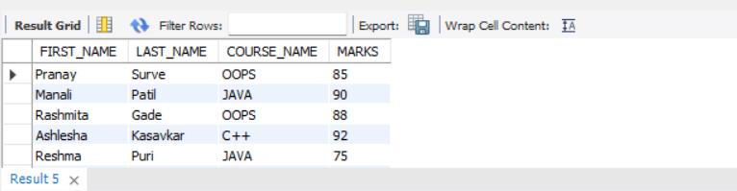

SELECT c.COURSE_NAME, AVG(s.MARKS) AS AverageMarks

FROM Student s

JOIN Course c ON s.COURSE_ID = c.COURSE_ID

GROUP BY c.COURSE_NAME;

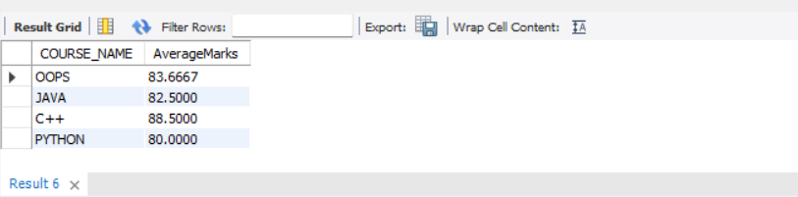

2.  Create database for hospital management system & Perform the following tasks:

a. Create HEALTH CARE WORKERS table with following attributes (EMPLOYEE_ID , FIRST_NAME, LAST_NAME,EMAIL, PHONE_NUMBER, HIRE_DATE, SALARY, DESIGNATION).

b. Create PATIENT table with following attributes (PATIENT_ID,NAME, PHONE_NUMBER).

c. Write a SQL statement to insert 10 records with your own value into the tables.

d. Write a query to get the names (first_name, last_name),Designation, salary.

e. Write a query to get the number of employees with the same Designation

f. Write a query to get employee name who are getting salary more than 25000.

g. Fetch HEALTH CARE WORKERS name using their employee id.

Program :-

CREATE DATABASE hospital_management;

USE hospital_management;



CREATE TABLE HEALTH_CARE_WORKERS (

EMPLOYEE_ID INT PRIMARY KEY,

FIRST_NAME VARCHAR(50),

LAST_NAME VARCHAR(50),

EMAIL VARCHAR(100),

PHONE_NUMBER VARCHAR(15),

HIRE_DATE DATE,

SALARY DECIMAL(10, 2),

DESIGNATION VARCHAR(50)

);



CREATE TABLE PATIENT (

PATIENT_ID INT PRIMARY KEY,

NAME VARCHAR(100),

PHONE_NUMBER VARCHAR(15)

);



INSERT INTO HEALTH_CARE_WORKERS (EMPLOYEE_ID, FIRST_NAME, LAST_NAME, EMAIL, PHONE_NUMBER, HIRE_DATE, SALARY, DESIGNATION) VALUES

(1, 'Pranay', 'Surve', 'pranay@gmail.com', '8594752815', '2022-01-01', 30000, 'Doctor'),

(2, 'Manali', 'Patil', 'manali@gmail.com', '7859482582', '2021-05-10', 32000, 'Nurse'),

(3, 'Rashmita', 'Gade', 'rashmita@gmail.com', '9875485895', '2020-02-15', 28000, 'Surgeon'),

(4, 'Ashlesha', 'Kasavkar', 'ashlesha@gmail.com', '9858475859', '2019-07-23', 25000, 'Technician'),

(5, 'Sampada', 'Margaj', 'sampada@gmail.com', '9658754852', '2018-11-11', 26000, 'Pharmacist'),

(6, 'Akshay', 'Barve', 'akshay@gmail.com', '7895485958', '2022-03-30', 27000, 'Doctor'),

(7, 'Mithila', 'Parab', 'mithila@gmail.com', '9858748596', '2021-12-12', 31000, 'Nurse'),

(8, 'Sejal', 'Patel', 'sejal@gmail.com', '9875896587', '2020-09-09', 29000, 'Surgeon'),

(9, 'Swati', 'Parab', 'swati@gmail.com', '7988545895', '2019-06-06', 24000, 'Technician'),

(10, 'Akshata', 'Patil', 'akshata@gmail.com', '9875896547', '2018-03-03', 22000, 'Pharmacist');



INSERT INTO PATIENT (PATIENT_ID, NAME, PHONE_NUMBER) VALUES

(1, 'Uday Gurav', '9876543210'),

(2, 'Reshma Dhule', '9876543211'),

(3, 'Akash Thosar', '9876543212'),

(4, 'Rinku Rajguru', '9876543213'),

(5, 'Neeraj Chopra', '9876543214'),

(6, 'Mansi Naik', '9876543215'),

(7, 'Aishwarya Rane', '9876543216'),

(8, 'Sanvi Dalvi', '9876543217'),

(9, 'Isha Dhoke', '9876543218'),

(10, 'Vanshita Patil', '9876543219');



SELECT FIRST_NAME, LAST_NAME, DESIGNATION, SALARY

FROM HEALTH_CARE_WORKERS;

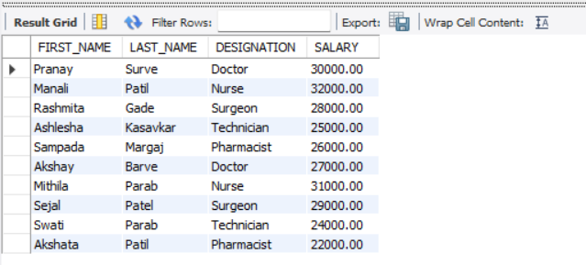

SELECT DESIGNATION, COUNT(*) AS Num_Employees

FROM HEALTH_CARE_WORKERS

GROUP BY DESIGNATION;

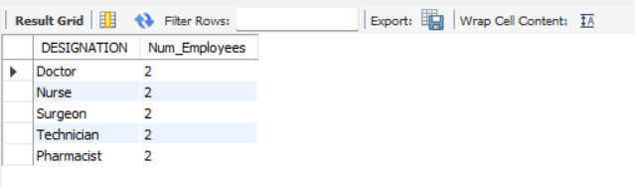

SELECT FIRST_NAME, LAST_NAME

FROM HEALTH_CARE_WORKERS

WHERE SALARY > 25000;

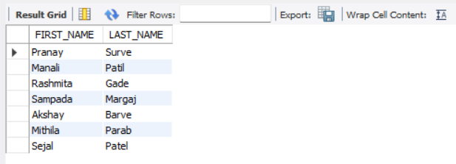

SELECT EMPLOYEE_ID, FIRST_NAME, LAST_NAME

FROM HEALTH_CARE_WORKERS

WHERE EMPLOYEE_ID = 1;

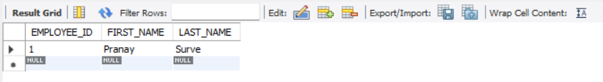

3.Consider two tables, customers and orders, with the following structures:

Customers Table: customer_id (Primary Key) first_name Last_name

Orders Table: order_id (Primary Key) customer_id (Foreign Key) order_date Total_amount

Write an SQL query to retrieve the first and last names of customers along with the order date and total amount of their orders.

Use an INNER JOIN to connect the two tables.

Program :-

CREATE DATABASE my_database;

USE my_database;



CREATE TABLE customers (

customer_id INT PRIMARY KEY AUTO_INCREMENT,

first_name VARCHAR(50),

last_name VARCHAR(50)

);



CREATE TABLE orders (

order_id INT PRIMARY KEY AUTO_INCREMENT,

customer_id INT,

order_date DATE,

total_amount DECIMAL(10, 2),

FOREIGN KEY (customer_id) REFERENCES customers(customer_id)

);



INSERT INTO customers (first_name, last_name) VALUES

('Pranay', 'Surve'),

('Manali', 'Patil'),

('Ashlesha', 'Kasavkar');



INSERT INTO orders (customer_id, order_date, total_amount) VALUES

(1, '2024-01-15', 150.00),

(2, '2024-02-20', 200.00),

(3, '2024-03-25', 250.00),

(1, '2024-04-30', 300.00);



SELECT

c.first_name,

c.last_name,

o.order_date,

o.total_amount

FROM

customers c

INNER JOIN

orders o

ON

c.customer_id = o.customer_id;

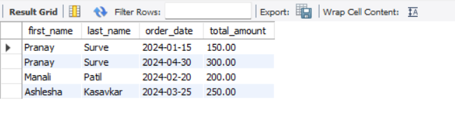

4.Consider two tables, departments and employees, with the following structures:

Departments Table: department_id (Primary Key) department_name

Employees Table: employee_id (Primary Key) first_name last_name department_id (Foreign Key)

Write an SQL query to retrieve a list of all departments and the names of employees who belong to each department. Use a LEFT JOIN to include departments that have no employees.

Program :-

CREATE DATABASE company;

USE company;



CREATE TABLE departments (

department_id INT PRIMARY KEY,

department_name VARCHAR(255) NOT NULL

);



CREATE TABLE employees (

employee_id INT PRIMARY KEY,

first_name VARCHAR(255) NOT NULL,

last_name VARCHAR(255) NOT NULL,

department_id INT,

FOREIGN KEY (department_id) REFERENCES departments(department_id)

);



INSERT INTO departments (department_id, department_name) VALUES

(1, 'Human Resources'),

(2, 'Finance'),

(3, 'Engineering'),

(4, 'Marketing');



INSERT INTO employees (employee_id, first_name, last_name, department_id) VALUES

(1, 'Pranay', 'Surve', 1),

(2, 'Manali', 'Patil', 2),

(3, 'Ashlesha', 'Kasavkar', 3),

(4, 'Mithila', 'Parab', 3);



SELECT

d.department_name,

e.first_name,

e.last_name

FROM

departments d

LEFT JOIN

employees e

ON

d.department_id = e.department_id

ORDER BY

d.department_name, e.last_name, e.first_name;

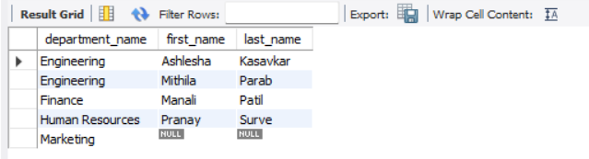

5. Write a program to show  JDBC connection with MYSQL and perform the following operations:

Create table Customer with following fields:

Custno, Custame,Custaddress,Phoneno, City, Pincode, Country

Insert 5 records in Customer table.

a.     Insert values

b.    Delete values

c.     update city name Shimla to Shilong.

d.    Show table in the console

Program :-

package com.tut;

import java.sql.Connection;

import java.sql.DriverManager;

import java.sql.Statement;

import java.sql.ResultSet;

public class JDBCExample {

// Database credentials

static final String ***url*** = "jdbc:mysql://localhost:3306/JDBCExample"; // replace with your database name

static final String ***user*** = "root"; // replace with your MySQL username

static final String ***password*** = "123456"; // replace with your MySQL password

public static void main(String[] args) {

Connection conn = null;

Statement stmt = null;

ResultSet rs = null;

try {

// Load MySQL JDBC Driver

Class.*forName*("com.mysql.cj.jdbc.Driver");

// Establish connection

conn = DriverManager.*getConnection*(***url***, ***user***, ***password***);

// Create statement object

stmt = conn.createStatement();

// Create Customer table

String createTableSQL = "CREATE TABLE Customer ("

+ "Custno INT, "

+ "Custname VARCHAR(50), "

+ "Custaddress VARCHAR(100), "

+ "Phoneno VARCHAR(15), "

+ "City VARCHAR(50), "

+ "Pincode VARCHAR(10), "

+ "Country VARCHAR(50))";

stmt.executeUpdate(createTableSQL);

// Insert 5 records

String insertSQL = "INSERT INTO Customer VALUES "

+ "(1, 'Pranay Surve', '123 Vileparle', '1234567890', 'Mumbai', '10001', 'India'), "

+ "(2, 'Manali Patil', '456 Virar', '2345678901', 'Kolhapur', '90001', 'India'), "

+ "(3, 'Ashlesha Kasavkar', '789 Thane', '3456789012', 'Pune', '60007', 'India'), "

+ "(4, 'Mithila Parab', '321 Dombivali', '4567890123', 'Nagpur', '77001', 'India'), "

+ "(5, 'Priyanka Pednekar', '654 Borivali', '5678901234', 'Ratnagiri', '85001', 'India')";

stmt.executeUpdate(insertSQL);

// Delete a record

String deleteSQL = "DELETE FROM Customer WHERE Custno = 5";

stmt.executeUpdate(deleteSQL);

// Update city name from Nagpur to Nanded

String updateSQL = "UPDATE Customer SET City = 'Nanded' WHERE City = 'Nagpur'";

stmt.executeUpdate(updateSQL);

// Show table in the console

String selectSQL = "SELECT * FROM Customer";

rs = stmt.executeQuery(selectSQL);

while (rs.next()) {

System.***out***.println("Custno: " + rs.getInt("Custno") +

", Custname: " + rs.getString("Custname") +

", Custaddress: " + rs.getString("Custaddress") +

", Phoneno: " + rs.getString("Phoneno") +

", City: " + rs.getString("City") +

", Pincode: " + rs.getString("Pincode") +

", Country: " + rs.getString("Country"));

}

} catch (Exception e) {

e.printStackTrace();

} finally {

// Close resources

try {

if (rs != null) rs.close();

if (stmt != null) stmt.close();

if (conn != null) conn.close();

} catch (Exception e) {

e.printStackTrace();

}

}

}

}

Output :-

Console Outpur :

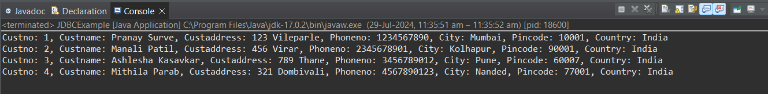

DB Output :

